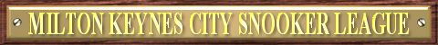
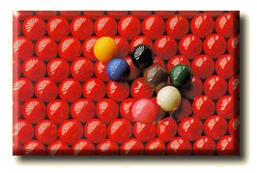

2011-2012 SEASON FIXTURES – REVISED 22/09/2011

 | Instructions |  |  |  |  |  | Premier A  Division |  | Away Team
Match Date |  | Match Number | Match Date | Match Number |  |  | Premier A  Division | Ball Breakers |  | Ball Dogs | BCC Harriers | Buckingham Bandits | Buckingham Eagles | Mavericks | MKSC Matchroom | Wolverton Warriors
19/09/2011 |  | Match 1 | 23/01/2012 | Match 14 |  |  |   Sponsored by:
26/09/2011 |  | Match 2 | 30/01/2012 | Match 1
03/10/2011 |  | Match 3 | 06/02/2012 | Match 2
10/10/2011 |  | Match 4 | 13/02/2012 | Match 3
17/10/2011 |  | Match 5 | 20/02/2012 | Match 4
24/10/2011 |  | Match 6 | 27/02/2012 | Match 5
31/10/2011 |  | Match 7 | 05/03/2012 | Match 6
07/11/2011 |  | Match 8 | 12/03/2012 | Match 7
14/11/2011 |  | Match 9 | 19/03/2012 | Match 8
21/11/2011 |  | Match 10 | 26/03/2012 | Match 9 |  |  | Home Team
28/11/2011 |  | Match 11 | 02/04/2012 | Match 10 |  |  | Ball Breakers |  |  | 2 | 11 | 6 | 5 | 14 | 8 | 3
05/12/2011 |  | Match 12 | 16/04/2012 | Match 11 |  |  | Ball Dogs | 9 |  |  | 5 | 14 | 11 | 3 | 6 | 1
12/12/2011 |  | Match 13 | 23/04/2012 | Match 12 |  |  | BCC Harriers | 4 |  | 12 |  | 1 | 13 | 9 | 10 | 7
09/01/2012 |  | Team Knockout R1 | 30/04/2012 | Match 13 |  |  | Buckingham Bandits | 13 |  | 7 | 8 |  | 10 | 5 | 2 | 11
16/01/2012 |  | Team Knockout R2 | 14/05/2012 | Match 14 |  |  | Buckingham Eagles | 12 |  | 4 | 6 | 3 |  | 1 | 14 | 9
Use the Match Date to find the Match Number above. On your division’s grid, where your team aligns, find the Match Number. The aligned teams are playing each other. 19th December is the xmas meeting. |  |  |  |  |  |  | Mavericks | 7 |  | 10 | 2 | 12 | 8 |  | 4 | 13
 |  |  |  |  |  |  | MKSC Matchroom | 1 |  | 13 | 3 | 9 | 7 | 11 |  | 5
 |  |  |  |  |  |  | Wolverton Warriors | 10 |  | 8 | 14 | 4 | 2 | 6 | 12

Premier B  Division |  | Away Team |  |  |  |  |  |  |  |  |  | First  Division |  | Away Team
 | BCC Tornadoes |  | Cranfield SC A | Foul 2 Visits | Herald Entertainers | MKSC Knights | MKSC Potters | MKSC Rockets | The Hunters |  |  | First  Division | BCC Comets |  | Bye | MKSC Allsorts | MKSC Old Codgers | MKSC Shooters | MKSC Stompers | The Rebels | The Tackers
Sponsored by: |  |  |  |  |  |  |  |  |  |  |  |   Sponsored by:
Home Team |  |  |  |  |  |  |  |  |  |  |  | Home Team
BCC Tornadoes |  |  | 8 | 2 | 7 | 11 | 5 | 3 | 13 |  |  | BCC Comets |  |  | 14 | 9 | 10 | 1 | 12 | 4 | 6
Cranfield SC A | 1 |  |  | 14 | 9 | 3 | 4 | 6 | 12 |  |  | Bye | 7 |  |  | 13 | 2 | 5 | 8 | 3 | 11
Foul 2 Visits | 9 |  | 7 |  | 4 | 12 | 13 | 1 | 10 |  |  | MKSC Allsorts | 2 |  | 6 |  | 8 | 14 | 4 | 12 | 10
Herald Entertainers | 14 |  | 2 | 11 |  | 6 | 10 | 5 | 8 |  |  | MKSC Old Codgers | 3 |  | 9 | 1 |  | 11 | 13 | 7 | 5
MKSC Knights | 4 |  | 10 | 5 | 13 |  | 1 | 9 | 7 |  |  | MKSC Shooters | 8 |  | 12 | 7 | 4 |  | 10 | 13 | 2
MKSC Potters | 12 |  | 11 | 6 | 3 | 8 |  | 14 | 2 |  |  | MKSC Stompers | 5 |  | 1 | 11 | 6 | 3 |  | 9 | 14
MKSC Rockets | 10 |  | 13 | 8 | 12 | 2 | 7 |  | 4 |  |  | The Rebels | 11 |  | 10 | 5 | 14 | 6 | 2 |  | 8
The Hunters | 6 |  | 5 | 3 | 1 | 14 | 9 | 11 |  |  |  | The Tackers | 13 |  | 4 | 3 | 12 | 9 | 7 | 1

  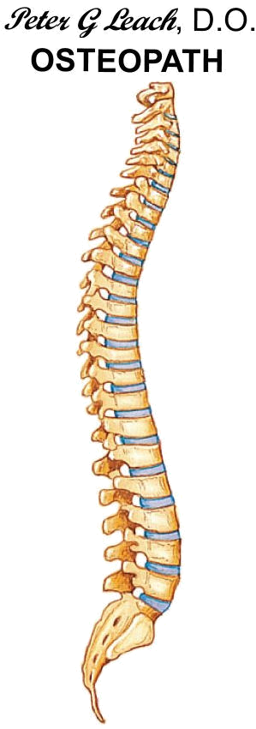  Second  Division |  | Away Team |  |  |  |  |  |  |  |  |  | The MKCSL would like to thank all this seasons sponsors:
 | Attention All Pockets |  | Blaize of Glory | Bye | Dreamteam | Herald Breakers | Herald Spiders | The Dodgers | The Unlikely Lads |  |  | 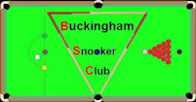

Sponsored by:


Home Team
Attention All Pockets |  |  | 11 | 6 | 3 | 9 | 12 | 1 | 14
Blaize of Glory | 4 |  |  | 1 | 7 | 5 | 9 | 13 | 10
Bye | 13 |  | 8 |  | 11 | 3 | 7 | 5 | 2
Dreamteam | 10 |  | 14 | 4 |  | 6 | 1 | 9 | 12
Herald Breakers | 2 |  | 12 | 10 | 13 |  | 4 | 7 | 8
Herald Spiders | 5 |  | 2 | 14 | 8 | 11 |  | 3 | 6
The Dodgers | 8 |  | 6 | 12 | 2 | 14 | 10 |  | 4
The Unlikely Lads | 7 |  | 3 | 9 | 5 | 1 | 13 | 11






For more information please visit the Milton Keynes City Snooker League’s web site at www.mkcsl.co.uk

