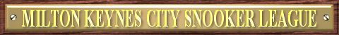
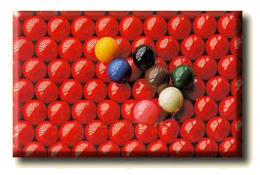

2012-2013 SEASON HANDICAP LEAGUE FIXTURES

 | Instructions |  |  |  |  |  | Premier  Division |  | Away Team
Match Date |  | Match Number | Match Date | Match Number |  |  | Premier  Division | Attention All Pockets |  | Buckingham Eagles | Herald Entertainers | Herald Spiders | Jedi | MKSC Old Codgers | Musketeers | The Dodgers
20/09/2012 |  | Match 1 | 14/01/2013 | Team Knockout R2 |  |  |   Sponsored by:
27/09/2012 |  | Match 2 | 17/01/2013 | Match 1
04/10/2012 |  | Match 3 | 24/01/2013 | Match 2
11/10/2012 |  | Match 4 | 31/01/2013 | Match 3
18/10/2012 |  | Match 5 | 07/02/2013 | Match 4
25/10/2012 |  | Match 6 | 21/02/2013 | Match 5
01/11/2012 |  | Match 7 | 28/02/2013 | Match 6
08/11/2012 |  | Match 8 | 07/03/2013 | Match 7
15/11/2012 |  | Match 9 | 14/03/2013 | Match 8
22/11/2012 |  | Match 10 | 21/03/2013 | Match 9 |  |  | Home Team
29/11/2012 |  | Match 11 | 28/03/2013 | Match 10 |  |  | Attention All Pockets |  |  | 4 | 10 | 7 | 1 | 9 | 13 | 5
06/12/2012 |  | Match 12 | 04/04/2013 | Match 11 |  |  | Buckingham Eagles | 11 |  |  | 2 | 8 | 5 | 10 | 7 | 13
13/12/2012 |  | Match 13 | 11/04/2013 | Match 12 |  |  | Herald Entertainers | 3 |  | 9 |  | 12 | 13 | 4 | 1 | 7
20/12/2012 |  | Match 14 | 18/04/2013 | Match 13 |  |  | Herald Spiders | 14 |  | 1 | 5 |  | 3 | 6 | 9 | 11
07/01/2013 |  | Team Knockout R1 | 25/04/2013 | Match 14 |  |  | Jedi | 8 |  | 12 | 6 | 10 |  | 14 | 4 | 2
Use the Match Date to find the Match Number above. On your division’s grid, where your team aligns, find the Match Number. The aligned teams are playing each other. 17th December is the xmas meeting. |  |  |  |  |  |  | MKSC Old Codgers | 2 |  | 3 | 11 | 13 | 7 |  | 5 | 8
 |  |  |  |  |  |  | Musketeers | 6 |  | 14 | 8 | 2 | 11 | 12 |  | 3
 |  |  |  |  |  |  | The Dodgers | 12 |  | 6 | 14 | 4 | 9 | 1 | 10

The MKCSL would like to thank all this seasons Sponsors:

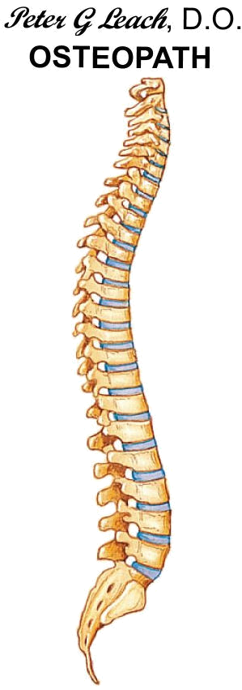



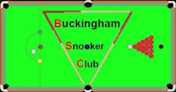


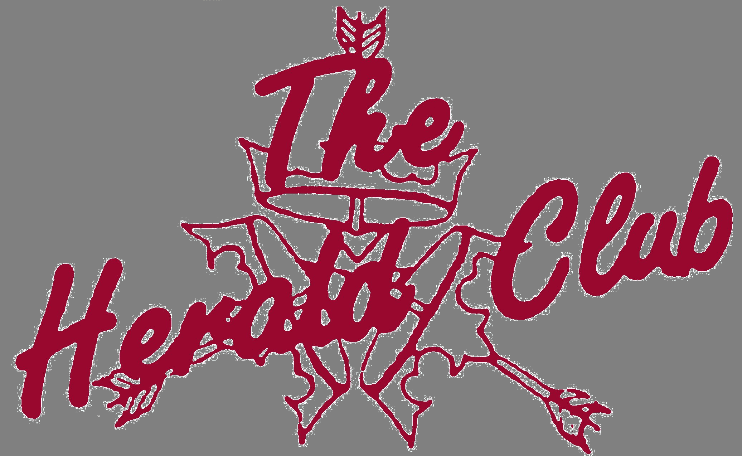



For more information please visit the Milton Keynes City Snooker League’s web site at www.mkcsl.co.uk

