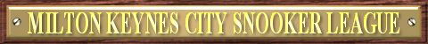
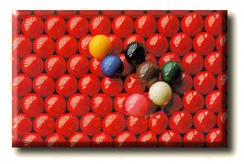

2012-2013 SEASON SCRATCH LEAGUE FIXTURES

 | Instructions |  |  |  |  |  | Premier A  Division |  | Away Team
Match Date |  | Match Number | Match Date | Match Number |  |  | Premier A  Division | BCC Harriers |  | Buckingham Bandits | Buckingham Eagles | Foul 2 Visits | Jedi | MKSC Matchroom | The Hunters | Wolverton Warriors
17/09/2012 |  | Match 1 | 21/01/2013 | Match 14 |  |  |   Sponsored by:
24/09/2012 |  | Match 2 | 28/01/2013 | Match 1
01/10/2012 |  | Match 3 | 04/02/2013 | Match 2
08/10/2012 |  | Match 4 | 11/02/2013 | Match 3
15/10/2012 |  | Match 5 | 18/02/2013 | Match 4
22/10/2012 |  | Match 6 | 25/02/2013 | Match 5
29/10/2012 |  | Match 7 | 04/03/2013 | Match 6
05/11/2012 |  | Match 8 | 11/03/2013 | Match 7
12/11/2012 |  | Match 9 | 18/03/2013 | Match 8
19/11/2012 |  | Match 10 | 25/03/2013 | Match 9 |  |  | Home Team
26/11/2012 |  | Match 11 | 08/04/2013 | Match 10 |  |  | BCC Harriers |  |  | 6 | 11 | 3 | 14 | 5 | 1 | 9
03/12/2012 |  | Match 12 | 15/04/2013 | Match 11 |  |  | Buckingham Bandits | 13 |  |  | 5 | 7 | 2 | 8 | 11 | 10
10/12/2012 |  | Match 13 | 22/04/2013 | Match 12 |  |  | Buckingham Eagles | 4 |  | 12 |  | 1 | 6 | 3 | 9 | 14
07/01/2013 |  | Team Knockout R1 | 29/04/2013 | Match 13 |  |  | Foul 2 Visits | 10 |  | 14 | 8 |  | 12 | 2 | 6 | 4
14/01/2013 |  | Team Knockout R2 | 13/05/2013 | Match 14 |  |  | Jedi | 7 |  | 9 | 13 | 5 |  | 11 | 3 | 1
Use the Match Date to find the Match Number above. On your division’s grid, where your team aligns, find the Match Number. The aligned teams are playing each other. 17th December is the xmas meeting. |  |  |  |  |  |  | MKSC Matchroom | 12 |  | 1 | 10 | 9 | 4 |  | 14 | 6
 |  |  |  |  |  |  | The Hunters | 8 |  | 4 | 2 | 13 | 10 | 7 |  | 12
 |  |  |  |  |  |  | Wolverton Warriors | 2 |  | 3 | 7 | 11 | 8 | 13 | 5

Premier B  Division |  | Away Team |  |  |  |  |  |  |  |  |  | First  Division |  | Away Team
 | Ball Breakers |  | BCC Tornadoes | MKSC Allsorts | MKSC Bad Buoys | MKSC Knights | MKSC Rockets | MKSC Shooters | MKSC Stompers |  |  | First  Division | Baize of Glory |  | BCC Comets | Dreamteam | Herald Spiders | MKSC Old Codgers | MKSC Potters | The Dodgers | The Tackers
Sponsored by: |  |  |  |  |  |  |  |  |  |  |  |   Sponsored by:
Home Team |  |  |  |  |  |  |  |  |  |  |  | Home Team
Ball Breakers |  |  | 3 | 11 | 9 | 13 | 5 | 7 | 1 |  |  | Baize of Glory |  |  | 14 | 4 | 1 | 6 | 12 | 3 | 9
BCC Tornadoes | 10 |  |  | 14 | 6 | 4 | 8 | 2 | 12 |  |  | BCC Comets | 7 |  |  | 5 | 13 | 11 | 1 | 9 | 3
MKSC Allsorts | 4 |  | 7 |  | 12 | 2 | 13 | 8 | 10 |  |  | Dreamteam | 11 |  | 12 |  | 3 | 14 | 9 | 1 | 6
MKSC Bad Buoys | 2 |  | 13 | 5 |  | 8 | 7 | 10 | 4 |  |  | Herald Spiders | 8 |  | 6 | 10 |  | 2 | 14 | 4 | 12
MKSC Knights | 6 |  | 11 | 9 | 1 |  | 3 | 12 | 14 |  |  | MKSC Old Codgers | 13 |  | 4 | 7 | 9 |  | 3 | 12 | 1
MKSC Rockets | 12 |  | 1 | 6 | 14 | 10 |  | 4 | 9 |  |  | MKSC Potters | 5 |  | 8 | 2 | 7 | 10 |  | 13 | 4
MKSC Shooters | 14 |  | 9 | 1 | 3 | 5 | 11 |  | 6 |  |  | The Dodgers | 10 |  | 2 | 8 | 11 | 5 | 6 |  | 14
MKSC Stompers | 8 |  | 5 | 3 | 11 | 7 | 2 | 13 |  |  |  | The Tackers | 2 |  | 10 | 13 | 5 | 8 | 11 | 7

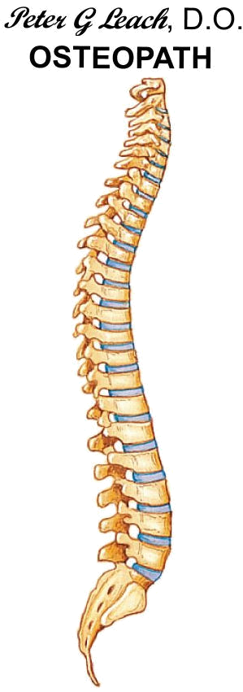
The MKCSL would like to thank all this seasons Sponsors:


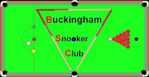





For more information please visit the Milton Keynes City Snooker League’s web site at www.mkcsl.co.uk

